

Safeguarding and Child Protection Policy

Document Owner | The Board of Trustees
Date last modified | January 2026
Related policies/documents | Whistleblowing  Equality & Diversity  Risk Assessment  Code of Conduct  Health & Safety
Date of next review | January 2027

INDEX

1. Introduction | Page 3
2. Accessibility | Page 3
3. Scope and eligibility | Page 3
4. Definitions | Page 4
5. Main principles | Page 5-8
6. Key Contact Information, Reporting Procedures & 1-to 1 mentoring Procedure | Page 8-15

1. INTRODUCTION

Wendover Youth Centre (WYC) and its Board of Trustees (‘the Board’) are firmly committed to the welfare of all young people who use its facilities and will do all it can to protect them from physical, sexual and emotional harm.

The purpose of this policy is to help ensure that activities undertaken by Wendover Youth Centre with children and young people up to the age of 18:
· Take appropriate account of WYC’s responsibility for protecting children and young people from abuse
· Minimises as far as reasonably possible the risk that those taking part will suffer serious injuries
· Is enjoyable, adventurous and rewarding for all involved
· Complies with legislation and national guidance in the UK.

1.1 Legal framework
This policy has been drawn up on the basis of law and guidance that seeks to protect children, namely:
- Children Act 1989
- United Convention of the Rights of the Child 1991
- Data Protection Act 1998
- Sexual Offences Act 2003
- Children Act 2004
- Protection of Freedoms Act 2012
- Keeping Children Safe in Education (September 2021)
- What to do if you’re worried a child is being abused: Advice for practitioners (March 2015)
- Relevant government guidance on safeguarding children

2. ACCESSIBILITY

1.
If any aspect of this policy or procedure causes you difficulty on account of any disability that you may have, or if you need assistance because English is not your first language, you should raise this with the Administrator (Admin@wendoveryouth.co.uk ), who will make appropriate arrangements.

3. SCOPE AND ELIGIBILITY

2.
This policy sets out the practices for ensuring appropriate safeguarding and applies to all activities and areas of work undertaken by Wendover Youth Centre that include children and young people up to the age of 18.

This policy applies to all employees, workers, volunteers and trainees (collectively referred to as “workers” in the remainder of this policy).

This policy is not contractual, it does not form part of employees’ terms and conditions of employment.

Wendover Youth Centre reserves the right to amend this Policy and any accompanying documentation from time to time.

4. DEFINITIONS

4.1. Safeguards

These are measures that an organisation puts in place to help reduce the risk of children, young people and adults being harmed.

4.2. Child Protection

This is a part of Safeguarding. It refers to the action taken to protect specific children from abuse or neglect. A child protection response may be necessary in any case where a child or young person under the age of 18 may have been subject to abuse or may be at risk of abuse.
An appropriate Child Protection approach should include policies, processes, procedures and measures to guide staff and volunteers in what to do if they are concerned that a child or young person may be at risk, and to empower children, young people and/or their families to seek help if they are worried.

5. MAIN PRINCIPLES AND PROCEDURES

5.1. Recruitment, Induction and Supervision

One of the most valuable and important parts of Wendover Youth Centre is our people, whether these are paid staff or volunteers. It is, therefore, important to ensure we are able to recruit the best people for the role, as well as giving them the right level of training and ongoing support in order to effectively safeguard the Children and Young People who come into contact with WYC.

5.1.1. Recruitment

We will ensure the following:
· All roles have a clear job description and person specification
· We will have a process for shortlisting candidates that involves more than one person
· We will have a face-to-face interview or meeting with a panel of more than one person

5.1.2. Checks and References

We will ensure that:
· All applicants provide at least two references before appointment and for one of these to be from the most recent place worked or volunteered (assuming they have worked or volunteered before)
· Applicants provide proof of identity and original copies of any relevant qualifications
· Applicants complete all the checks that are relevant for the role. These may include right to work checks, criminal record checks, overseas checks and will complete an enhanced DBS check before they start to work or volunteer.

5.1.3. Inducting Workers

The following will take place:
· A copy of this policy will be provided to all staff and volunteers for them to read and understand
· Volunteers will be placed alongside a fully vetted and trained member of staff until satisfactory checks have been completed
· There will be a trial period for staff and volunteers, with a review before they are confirmed in post.

5.1.4. Ongoing Supervision and Support

WYC will ensure:
· That there is regular supervision, and support for all staff and volunteers.
· That all employees have an annual performance appraisal.
· That all Board members, staff and volunteers complete appropriate Safeguarding (Child Protection) training courses on joining and will take refresher courses every three years.

5.1.6. Visitors

Visitors to the Centre will be asked to show the Centre Manager/session lead a valid and in date DBS certificate. If they do not have this, they will be under supervision by a member of staff throughout their whole stay and will be made visible with a visitor lanyard.

They will have to alert the Centre Manager/session lead as soon as they enter the building and as soon as they leave.

5.2. Protecting Children and Young People

The WYC will ensure that measures are in place to protect children and young people who are identified as being at possible risk of abuse and neglect, as well as having relevant procedures for raising and managing any allegations.

5.2.1. Abuse
Child abuse is defined as the intentional harm to a child by an adult or another child. This can be a one-off incident or a repeated action.

There are four main types of abuse to which children and young people can be subjected:
· Physical abuse - this is where someone physically harms a child. This can include physical violence or extremities like drowning or poisoning.
· Neglect - this is when a child’s basic needs are not met by an authority figure or caregiver. It can be:
    - Physical - where a child’s basic needs like nutrition, clothing or shelter are not met.
    - Educational - where a child is not given the chance of an education
    - Emotional - when a child does not get the nurture or simulation they need from the caregiver
    - Medical - when a child has their access to medical care restricted.
· Sexual abuse - this is where sexual contact is made with a child by an adult or another child. This can be with or without the consent of the child. Examples of this can be forced penetration, production or distribution of child pornography or forcing a child to masturbate in front of other people.
· Emotional abuse - this is when a child suffers emotional mistreatment. This can be to deliberately scare, humiliate, isolate or ignore a child. This can range from constantly criticising a child to trying to control their entire lives or being an absent parent.

If any of these occur, children and young people often display problems in the following areas:
· Behaviour
· Drugs and alcohol
· Education
· Physical evidence e.g., bruising
· Mental health
· Relationships

A young person may disclose that they are being abused; they may show signs of abuse; or they may speak about third party abuse.

5.2.2. E-Safety

When a young person expresses that they are online frequently, we will promote e-safety by reminding them of the basic essentials when using certain communication systems. If the young person is below the age required for the platform, we will inform them of this and note it down. We will then raise this concern with parents and will check in occasionally with the young person for any possible developments. We will then deal with these concerns as outlined below in the subsequent section.

5.2.3. Dealing with Allegations

The following procedures will apply in the identification or suspicion of abuse towards a child or young person.

If abuse is suspected:
· Observations, conversations or concerns will be recorded, signed and dated. This can be via paper or digital means.
· The matter must not be investigated or discussed with anyone other than the Safeguarding Officer or Safeguarding Lead.
· The Safeguarding Officer or Safeguarding Lead will assess the information and contact the appropriate local statutory services e.g., schools/social services.

If abuse is reported/alleged:

Allegations should be reported to the Safeguarding Lead or Safeguarding Officer.

Safeguarding Lead
Name: Samantha Richardson
Samantha@wendoveryouth.co.uk

Safeguarding Officer
Name : Shanie Noakes
Shanie@wendoveryouth.co.uk

Information gathering
· The individual will be listened to and encouraged to speak without interruption, comment or judgement.
· It will be explained that information may need to be shared in certain circumstances.
· A written account of the report or allegation will be made, signed and dated by two people and the information passed to the Safeguarding Officer or Safeguarding Lead.
Investigation
· The matter will not be investigated by anyone other than the Safeguarding Officer or Safeguarding Lead.
· Any investigation will be conducted as soon as reasonably possible.
· If the allegation concerns a member of staff or volunteer, consideration will be given to the suspension of the person involved taking account of the risks to other young people and the individual concerned
· If the allegation involves a club member, contact will be made with the young person’s parents/carers (if appropriate and does not involve the allegation being against the parent/carer) to advise them of the process.
Communication
· The Board via the Chair are to be kept informed of the nature of the issue without revealing the name(s) of the individual(s) concerned.
· The Safeguarding Lead/Safeguarding Officer will inform the appropriate statutory service (school or Social Services).
o If a child or young person is in immediate risk of harm then call 999
- Otherwise call the First Response team within Children’s Social Care via 01296 383962 or e-mail secure-cypfirstresponse@buckscc.gov.uk

Allegations relating to Staff or Volunteers
If there is an allegation relating to a worker of WYC this will be reported to LADO (Local Authority Designated Officer) secure-LADO@buckscc.gov.uk 01296 382070
Allegations may include that they:
· Have harmed a child or young person
· Committed an offence against a child or young person
· Have behaved towards a child or children in a way that indicates they may pose a risk of harm to children.
Assuming it is appropriate, the details of the allegations will be passed to the Safeguarding Officer/Safeguarding Lead as soon as possible.

5.3. Running Safe Activities and Events

When working with children and young people, we know that they need and want to take risks when they play and cannot grow and thrive without learning to cope with the possibility that things can sometimes go wrong.
Our role is to successfully manage risks and keep children and young people safe, while simultaneously providing the benefits of adventurous and healthy activities.

In order to do this, we have the following policies:
· Health and Safety Policy
· Risk Assessment Policy

In addition to our policies, we will also ensure we have up to date information and consent including:
· Consent for activities from parents/carers and children and young people as appropriate
· Consent for photography, including information on how and where the images will be used
· Details about the child or young person’s needs (e.g., medical, dietary, allergies, care and support needs)
· Emergency contact details for each child or young person
When working with young people doing one-to-one mentoring sessions, WYC has developed a procedure which the staff follow. This is to ensure the young person and worker are safe. This can be found below in section 6.

5.4. Sharing information with other Agencies
When partnering or hiring an outside professional or organisation, WYC will ensure that a contractors/partners checklist is adhered to, to ensure that the young people are safeguarded and that good practice, policies and procedures are followed. This checklist is to be completed before work from the contractors/partner begins and signed off by the Centre Manager.

5.5. Sharing information with other Agencies
If there is a case where it is felt that sharing the information of a case with other agencies (e.g., school, child services) is appropriate then this needs to be approved by the Safeguarding Lead and Safeguarding Officer. Sharing concerns about a child or young person’s wellbeing helps professionals build a clearer picture of the child’s life and gain a better understanding of any risks the child is facing.
Information sharing is a vital part of making sure that a child or young person and their
family receive the right support at the right time and prevents a concerning situation from
becoming more serious.

5.6. Sharing Photos/Videos
To promote the work WYC does and evidence it, it is common practice for images of young people to be captured on sessions. Once images are captured, they are sent to the social media manager within two days of said session. The subjects within the image are then identified and referenced if we have photo consent. If this parental consent is present, these images will be posted to our social media channels and/or website.
Each parent will be asked if they would like to grant photo consent for their child and has the right to remove this at any time, in line with our data protection policy.

After the images are captured, they are stored in a secure google drive folder. These can then be downloaded to be posted and deleted from all hardware after being shared.

5.7. Code of Conduct

The Board, Staff and Volunteers of Wendover Youth Centre will all adhere to the guidelines outlined in the WYC Code of Conduct Policy as to how children, young people and adults interact with each other.

6. 1 to 1 Mentoring Procedure

Statement:
This operating procedure sets out the purpose and parameters for those engaged in 1:1 work with young people either on a regular basis (Mentoring) or occasionally under the authority of WYC. At WYC a Young Person (youth) is defined as a child between the ages of 9 and 18 years. All adults (staff/volunteers) engaging in 1:1 work should be appropriately checked including an enhanced DBS disclosure, two references and for volunteers, a volunteer agreement.

One-to-one Processes:
One-to-one (1:1)
1:1 work is an essential aspect of our youth work but needs to be undertaken wisely. A 1:1 session is a meeting with an individual young person as a one off or as part of a wider mentoring agreement. Whilst youth workers may publicise their availability for 1:1 sessions, meetings will be arranged at the young person or parent/guardian’s request. The purpose of a 1:1 meeting is to listen to any issues a young person may wish to discuss, help them process or deal with an emerging situation and in both cases provide oral support and encouragement. Youth Workers may suggest that a young person consider more structured mentoring if 1:1 meetings become more regular or issues discussed are continuing or ongoing. 1:1 meetings should be considered mentoring if they become a regular, programmed event. In this instance mentoring agreements (see below) and guidelines must be followed.

Mentoring
This relates to occasions when a regular 1:1 meeting is agreed over a period of time with a mentor. To ensure good practice is adopted the young person should initiate this by contacting the youth worker who will then make appropriate arrangements for a mentor in accordance with this procedure. Youth workers may suggest that a young person considers mentoring owing to the nature or frequency of the individual 1:1 meetings. Mentors should be a qualified member of staff, part of the WYC team, with safeguarding training and having passed the appropriate checks (DBS). Mentoring is to encourage and support a young person on a regular basis or for a set period of time in response to their personal circumstances.
Mentoring agreement
Before mentoring begins all the parties involved (mentee, the school, mentor, parents) must complete an agreement explaining how they intend to operate. The mentoring agreement will clearly state the aims, conditions and frequency of meetings before a mentoring relationship formally starts. Mentees and parents/guardians must agree before the mentoring can begin.

Parameters
Ideally,1:1 work should take place on WYC’s premises. A second adult should be in the building. The young person should be made aware of the existence of this person and that they are available to them. The school, parent/guardian should be advised of the date and time of the sessions.
A 1:1 situation has the potential to make the child/young person more vulnerable to harm by those who seek to exploit their position of trust. Adults working in these situations with children and young people may also be more vulnerable to unjust or unfounded allegations being made against them. Both possibilities should be recognised so that reasonable and sensible precautions are taken. Every attempt should be made to ensure the safety and security of children and young people and the adults who work with them.

Workers must:
- avoid meetings with a young person in remote, secluded areas
- always inform the school beforehand, assessing the need to have another adult present or close by
- avoid phone and social media contact with the young person
- always report any situation where a young person becomes distressed or angry to a senior colleague
- carefully consider the needs and circumstances of the young person when in a 1:1 situation.
- be aware of Safeguarding policy and procedures to report concerns.
- ensure that the door is ajar when left alone in a room with a young person, even for a limited time period.

7. KEY CONTACT DETAILS/LINKS

6.
Safeguarding Lead
Samantha Richardson
Email: Samantha@wendoveryouth.co.uk

Safeguarding Officer
Email: Shanie@wendoveryouth.co.uk

Bucks Council First Response Team
9am to 5:30pm Monday to Thursday, 9am to 5pm Friday - 01296383962
Before 9am, after 5:30pm (5pm on a Friday) or at weekends (Emergency Duty Team) - 08009997677

WYC Safeguarding report form
https://docs.google.com/forms/d/e/1FAIpQLSemduYdLVZ3cNkJF_UpbJ_vASDOwMcx4p_Z0AMh6yfRAlOqEw/viewform

The completed Safeguarding report forms are kept within a secure google drive that only the Safeguarding Lead and Safeguarding Officer have access to.

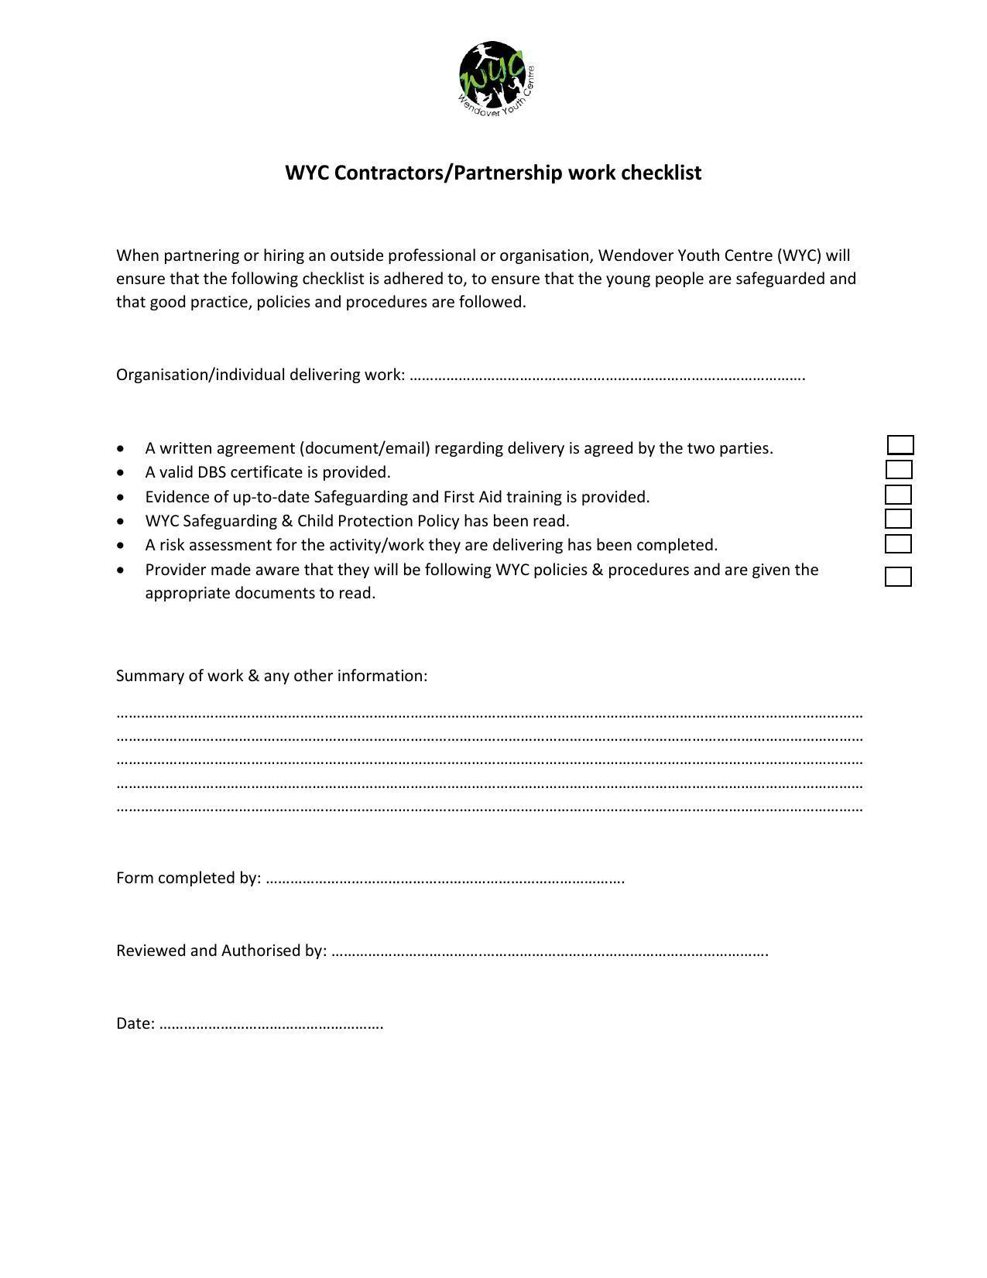
Staff/Volunteer & young leader Safeguarding guidance flow diagram
find
Report your concerns immediately to the Safeguarding Lead//Safeguarding Officer.
Safeguarding Lead will evaluate the incident and/or make a referral to the Safeguarding Officer.
All information disclosed will be recorded and stored securely.
Hand over notes and inform Safeguarding Lead during or after the session.
The information relating to this concern/incident is confidential and must not be discussed with any other person.
Make a written note of the information/observation and include a record of the time, date and person.
At risk is, or may be subject to being:
Harmed, abused, neglected
You are approached by a child, young person, adult at risk with a disclosure that they are:
Safeguarding Lead/Safeguarding Officer will review and investigate, follow the process in the WYC Safeguarding policy process. This may result in a formal disciplinary action being taken and/or a referral made to the LADO (Local Authority Designated Officer).
If the matter is referred to external authorities, you may be asked for a formal statement of your concerns for subsequent external enquiries.
Person who reported concern/disclosure will be updated within 1 month.
Key Contacts:
Safeguarding Lead –Samantha Richardson - Samantha@wendoveryouth.co.uk
Safeguarding Officer – Shanie Noakes
Shanie@wendoveryouth.co.uk

Person who reported concern/disclosure will be updated within 1 working week.
If the Safeguarding Lead is not available, then contact the Safeguarding Officer.
You are concerned that the behaviour of a member of staff or other person is threatening or potentially threatening the well-being of a child, young person or adult at risk.
In all situations, you must provide an outline of your concerns in writing.
You are informed by someone else:
Parents, Public or fellow staff or volunteers that a child, young person or adult is:
You have observed and you are concerned that a child, young person or adult is:

